LINUX FUNDAMENTALS:

# SYSTEM INFORMATION:

## How to connect Openvpn:

#Connecting to the openvpn server of the HackTheBox Academics is necessary as per the connection of the ssh client further.

* Check for the Openvpn service in the terminal by typing the command “***openvpn --version***”.
* If not then install it by using “***sudo apt get install openvpn***”.
* If present the terminal will give the version of the output as the version of the service.

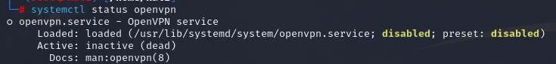#We can check if the service is active or not by typing the command “***systemctl service openvpn***” as below.

* Download the VPN connection file from the module page.
* Change the directory to the downloaded space by using “***cd***”.
* Connect to the vpn using the key file by the command ***“openvpn <filename>***”.

#Exclude the pointers.